

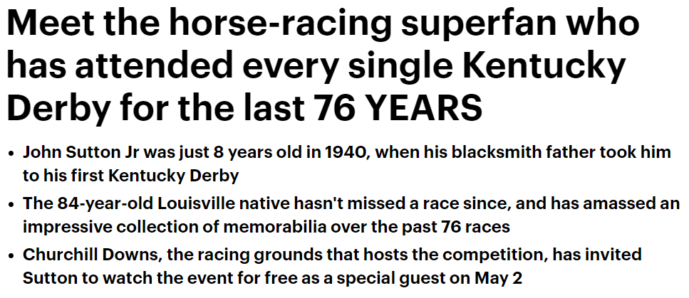



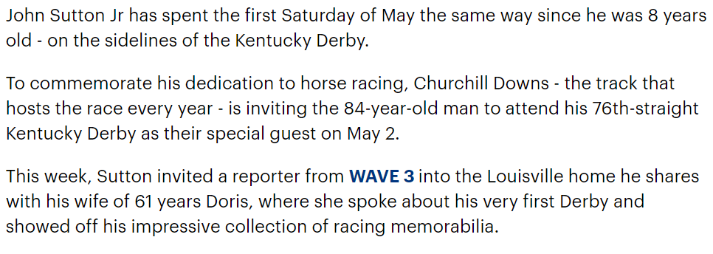

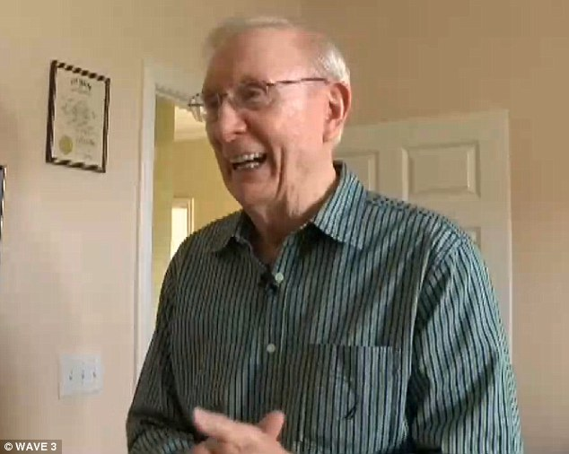

**Dedicated: Churchill Downs is inviting John Sutton Jr, 84, to attend the Kentucky Derby as their special guest on May 2, since he has attended every race for the past 76 years**

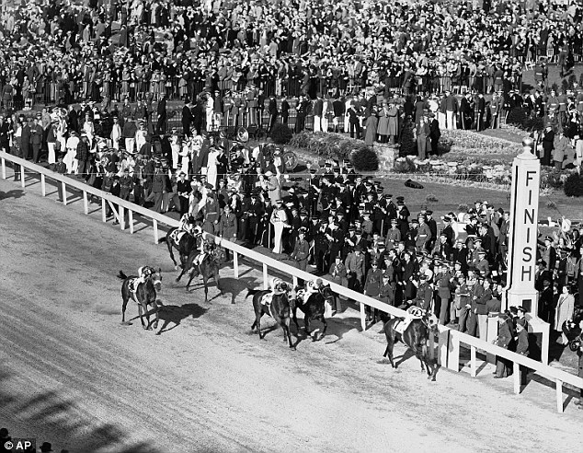

**Winner, winner: Sutton was just 8 years old in 1940 when his father brought him to his first race, and the two bet against the favorite on a horse called Gallahadion, which ended up winning the race**

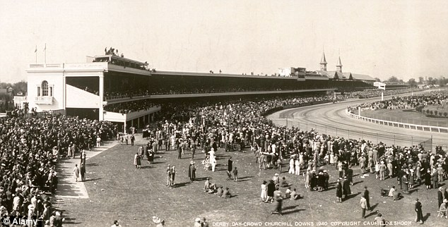

**Among the masses: Above, a view of the crowds at Churchill Downs on the day of the 1940 race**

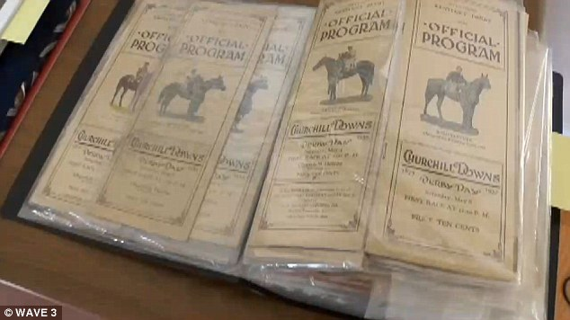

**Living history: Sutton has collected a program from every Kentucky Derby he has attended and keeps them in a binder at home. Above, some of the early years**

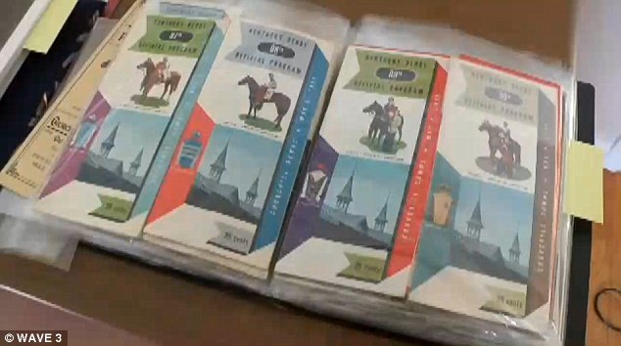

**Through the years: The Derby programs got more and more colorful over the years**

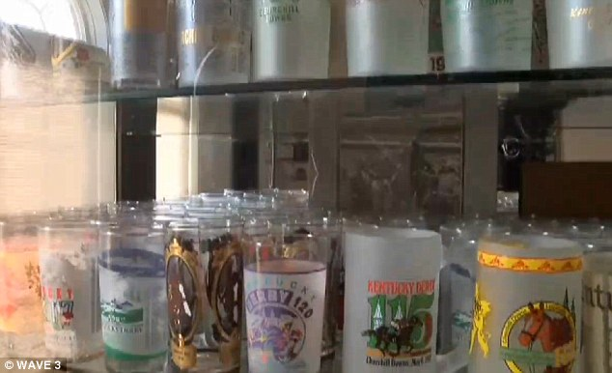

**Keepsakes: In addition to programs, Sutton has Kentucky Derby glasses stretching back more than seven decades**

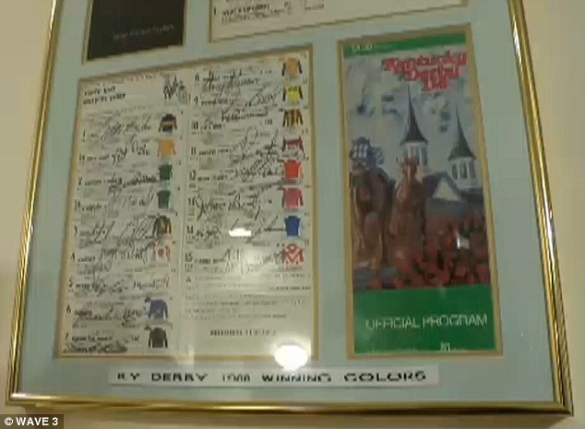

**Autographs: Sutton got jockeys to sign several of his programs, which he proudly displays in frames at home**

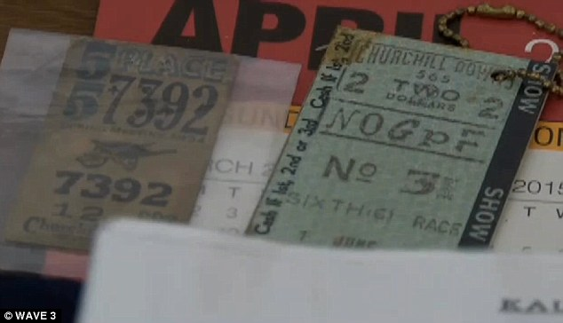

**Entry: Above, some of the tickets Sutton has collected from the Kentucky Derby since 1940**

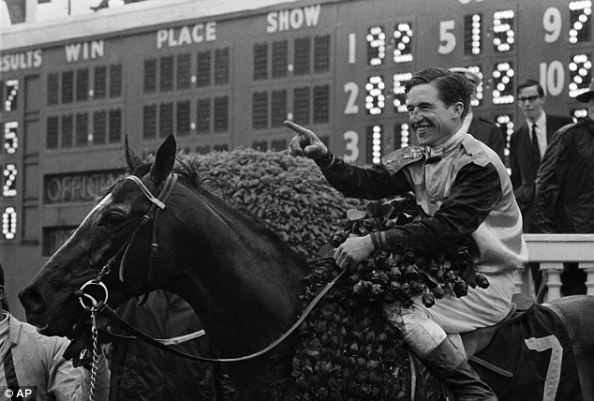

**An eye for champions: Sutton won $600 dollars in 19567, when he bet on the winning horse Proud Clarion. Proud Clarion and jockey Bobby Ussery pictured above after placing first at Churchill Downs**

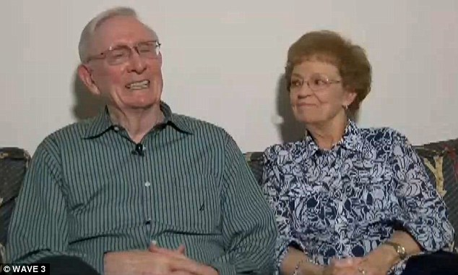

**Getting ready for the race: Sutton (left)  pictured above with his wife of 61 years, Doris (right)**

Sutton says he was just 8 years old in 1940 when his blacksmith father brought him to his first Kentucky Derby.

'Once the race started, we would crash the gates, so to speak to get on the rail or wherever we could get,' Sutton recalled.

That year, Sutton and his father decided to bet on the horse Gallahadion, instead of the favorite, Bimelech.

And to their delight, Gallahadion pulled through to an unexpected victory that helped cement Sutton's love for the sport.

